This document is a preview document of the material to be used for discussion and feedback at the CALMAC meetings of September 3rd in the Los Angeles area and September 4th in San Francisco for the New California Evaluation Framework/Roadmap project.

Given the length of this document, a Table of Contents is provided for ease of use.

Table of Contents

Introduction and Overview of September CALMAC Meetings 1
Evaluation Support Studies 2
Portfolio Level Evaluation Studies 3
Umbrella Framework for Program-Level Evaluations 3
Overview of the Program-Level Evaluation New Framework/Roadmap 6
Evaluation Use of Program Theory and Program Logic Models 7
Uncertainty and Sampling 8
Impact Evaluation 9
Measurement & Verification (M&V) 18
Process Evaluation Framework 29
Market Evaluation 32
Information and Education Framework 35
Non Energy Benefits Evaluation Framework 37
Next Steps After September 3rd and 4th CALMAC Meetings 39

Introduction and Overview of September CALMAC Meetings

- Introduction of Key Presenters and Project Advisory Group
- Very brief introduction to project
CPUC direction is to establish a standard evaluation Framework that assures that programs will be evaluated so that policy makers can understand the energy and demand savings being delivered by all programs and to be able to reliably forecast energy resources available from energy programs.
(Individuals unfamiliar with this work effort are directed to the CALMAC meeting notes posted on the CALMAC website from the project initiation meeting for more detail on the logic and design of this project.)
- Primary purpose of CALMAC meetings is to present the early Framework approach, obtain feedback, and potentially solicit more detailed additional feedback.
- Need to get through all topics in one day. So try to keep to approximately ½ hour per topic.
- Evaluation funding may be used for program-specific evaluation studies, evaluation support studies, portfolio level studies, and other research as supports the evaluation and/or knowledge needed to improve evaluation efforts or program design and improvement efforts.
- This project is primarily focused upon program-specific evaluation studies (to include the issue of consolidation or program-group evaluation).
- But will also make general recommendations concerning Evaluation Support Studies, Portfolio Level Evaluations, and Use of Evaluation Results.
- It does not address evaluation funding.
- The framework is a forward looking document and does not specifically address evaluation requirements for the 2004-2005 program solicitations.

Energy program research and evaluation not considered as part of the scope of this project are:
- Low-income programs
- Evaluating RD&D programs
- Overall regulatory structure or process
- Program design research or the other research support uses of evaluation funding

Evaluation Support Studies

Studies involving energy efficiency evaluation and research that are done on either a recurring or special issue basis to support program and portfolio evaluation planning and decision-making.

- Continuation of such studies on a periodic basis as needed to support the overall decision-making process.
- Recommendations of additional statewide or issue studies that should be considered (with CALMAC probably being the body responsible for selecting the studies proposed in any particular year).

At this time, the studies likely to be in this discussion list:
  - Measure Saturation Studies
  - Energy-Savings Potential Studies
  - Market Analysis (to include market share tracking, cost and cost differential for technologies, and as needed to support the Market Evaluation studies done)
  - Research that is more cost-effectively done at a statewide level or across programs periodically for updating key parameters for program design and evaluation assumptions (such as Avoided Cost studies, the DEER database update, the Framework project, the Best Practices Study, and perhaps persistence and measure retention studies ),
  - Issue based evaluation studies [such as, best/least-biased methods to use to econometrically derive net-to-gross; Creation of a standardized survey method and analysis for net-to-gross calibrated to econometrically derived NTG; Are the benefits of other standardization (Designated Unit of Measurement) worth the cost?; Vintage studies on impact evaluations to determine how often and in what circumstances impact evaluations can be conducted less than annually; Examination of peak method estimation and tools available to assist with this (default savings load shapes and accuracy of using such); Research activities to provide better links between evaluation output and procurement/supply analysis integration]
  - Portfolio Evaluation Studies (described and discussed below)

Portfolio Level Evaluation Studies

This is a class of evaluation studies that work with, evaluate, and assess the portfolio (grouping of programs) of Public Goods Charge programs or, potentially, the portfolio of energy efficiency efforts across PGC and procurement, or the portfolio of energy efficiency, demand-response, and renewable energy sources.

One of the primary types of Portfolio Evaluation is to look at:
- Aggregating energy and demand savings and ensuring no double-counting (a summative evaluation)
- Direct market studies and incorporate market effects that have been missed in program or market studies designed from groups of programs (i.e., adding in savings missed from study aggregations that “fell through” the accounting cracks)
- Examining portfolio level cost-effectiveness, to include all costs for all program types (resource, information, demonstrations, resource centers, infrastructure development)
- Looking at portfolio risk assessment (trade-offs between resource acquisition and market transformation; high risk and low risk programs/target markets; pilot, equity, technology development support versus established acquisition programs)

May wish to look at this summative evaluation bottom-up (adding up program-level evaluations) and match/compare/assess with top-down evaluation (statewide energy use, trends, causes of change, etc.).

Other types of Portfolio Level Evaluations or Assessment that could be considered:
- A formative portfolio evaluation that would use the above portfolio evaluation with potential studies, market studies, process evaluations, and market analyses to guide portfolio investment decisions on what types of efforts to continue or fund in the future.
- A gap analysis formative portfolio evaluation (based on the above)
- An exam of portfolio evaluations and program evaluations to determine needed changes in direction, timing, or support studies to direct more cost-efficient evaluations and changes/updates to the new Framework/Roadmap and/or Protocols.

Umbrella Framework for Program-Level Evaluations

A primary goal is to offer specific guidance on what is expected from the evaluation efforts, while providing flexibility and allowing innovation.

Where possible, our approach is to develop three possibilities:
- Prescriptive path
- Customized (within specific set of criteria)
3. Waiver Process (for expectations that do not fit within a standard program evaluation process, or to allow creative alternatives that can prove an alternative approach meets Framework principles but doesn’t fit within Customized criteria, or for instances in which an evaluation may not be needed or wanted for specific reasons)

Update of the evaluation process will be the responsibility of CALMAC. This project provides input as information is developed to help provide a base structure for program-level evaluation roadmaps.

All programs need to have an Evaluation Plan every year.
- The plan may propose no evaluations if that is indicated by the roadmaps
- Yet, the Evaluation Plan must provide evidence why evaluation not needed (or what types are needed)
- Goal = Critical thinking about evaluation every year
- The individual pathways provide input to what evaluations to conduct
- Overall schedule is another input to the development of the Evaluation Plan

A schedule will determine when and what type of evaluations a program needs to do. We may have different schedules for different types or sizes of programs, or types of evaluation.

Schedule could then be changed by a designated authority (CPUC, CALMAC) periodically as new information (e.g., vintaging study) or policy decisions are made.

An example of one possible schedule:

Evaluation Type | Year of Program Operation
Evaluation Type | Year 1 | Year 2 | Year 3 | Year 4 | Year 5 | Years 6 & beyond
Process | Conduct evaluation approx. 10-12 months into program operations |  | Conduct 2nd evaluation  (Incorporate and assess alongside impact findings.) |  |  | Based on program size, changes to program, and uncertainties in key evaluation parameters, develop plan for subsequent evaluations. Programs that are small, unchanging and with limited uncertainty will be infrequently evaluated and visa-versa.
Market progress  (for programs with market transfor-mation aspects) | Baseline if not already prepared | Assess market progress indicators as specified in evaluation plan for the program and program baseline |  | Conduct second assessment
Impact/ M&V | Review and adjustment of pre-program estimates based on initial field experience | Review and adjustment of pre-program estimates based on field experience to date | Conduct full impact evaluation using appropriate methods as discussed in impact evaluation section. |  | Conduct 2nd assessment
Education/ information program evaluation |  | Conduct effects evaluation. Assess $/effect. | Depending upon size of program and cost of evaluation, conduct effects evaluation annually. | See prior. | See prior.
Cost-effectiveness analyses | Conduct cost-effectiveness analysis* |  | Conduct cost-effectiveness analysis based on impact evaluation* |  | Conduct cost-effectiveness analysis based on impact evaluation*
Persistence |  |  |  |  |  | Schedule to be determined after assessment by CALMAC on value of information and decision if done at program-level or aggregate studies by market or other.
* Except for education/information only programs.

Study may provide a table outlining approximate costs for the different types of evaluations by evaluation goal and program size for those that do not have a handle on what the different types of evaluation might cost. This would allow organizations that are not familiar with evaluation costs to consider how evaluation can impact budgets.

Overview of the Program-Level Evaluation New Framework/Roadmap

- Policymakers require evaluation results of sufficient reliability to make resource supply decisions at the portfolio level. Reliability of findings is a driving factor in this Framework.

- All programs will use the Framework for evaluation planning.

- Different programs go through different parts of the Framework depending on program type and objectives.

- Program evaluations must deal with uncertainty issues in both planning and results reporting.

- There are sampling requirements for most evaluation components (e.g. impact, process, market effects and so on).

- Programs will be asked to include discussions on quality assessment and critical thinking about measurement problems, how these were dealt with, and remaining areas of potential bias or weaknesses.

- The process is an integrated planning process that should be tailored to program approval cycles.

Evaluation Use of Program Theory and Program Logic Models

- The use of Program Theory and Program Logic Models (PT/LM) can be of significant help in designing quality evaluations for all types of evaluations.
- These tools are critical for informing and in some cases guiding market evaluations and education/informational program effects evaluations.
- As a tool, one of the 1st steps in the evaluation planning process should include a review by the evaluator of the program theory, and if available the program logic model, as a tool to inform the development of a program evaluation plan. Alternatively, if there is no PT/LM the evaluator should lead the development of a program theory as a component of the evaluation project, in coordination with the program team so that the evaluators fully understand what the program is designed to accomplish, how the program will accomplish the established goals and the relationships between program objectives and program materials and operations. PT/LM models that are thorough and consistent with other research on the market in question are critical for quality market evaluations and education/information program effects evaluations. Their development, if unavailable, and use, however, should also be considered for other program types within funding constraints and competing evaluation demands.

Intent is to provide a small subsection in the Framework describing program theory and logic models and their use in the evaluation planning process, refer users to the prior Framework Study, and provide references for interested parties to other program theory and logic model publications that can be of use to the evaluation planning process. This is not to be a textbook on program theory or logic modeling, just a starting point. The Framework subsection will focus on the use of program theory and logic modeling as an evaluation support tool; rather than its larger uses with program design and program monitoring/management.

Uncertainty and Sampling

The discussion of uncertainty is focused primarily on the needs of evaluation managers and policy makers. Three aspects of uncertainty are discussed in the roadmap:

- Basic concepts – bias and statistical precision. Makes the point that conventional measures of statistical precision are misleading if there is risk of substantial bias from non-response, measurement error, model specification, etc.

- Integrating the results from multiple evaluation studies. Summarizes methods of meta-analysis useful for aggregating, integrating and contrasting the results of multiple evaluation studies.

- Allocation of resources to evaluation. Discusses various considerations and analytical methods that can help guide how resources are spread between various evaluation studies.

In most evaluation studies, a formal sample design is needed to guide the selection of a sample of projects, program participants, customers, etc., for data collection. The objective of sampling is to provide an unbiased extrapolation of the sample data to the target population with measurable statistical precision. The sampling section describes the elements of sampling design. The Sampling Performance Path may be one in which professional evaluators use these elements in a standard usage with some description of minimum consideration criteria.

The sampling section will also provide a step-by-step roadmap for applying simple random sampling and stratified ratio estimation. It will take the description developed, as described above, and create a step-by-step approach as the Sampling Prescriptive Path. The sampling roadmap will address sample size vs. expected statistical precision, efficient stratification, unbiased estimators, confidence intervals, estimation of the parameters needed for future sample designs, and guidelines for reporting results.

(Roadmap graphics are still being developed. A draft for discussion may be presented at the meetings, that is not ready for the early publication of this material.)

Impact Evaluation

The roadmap reflects the following general concepts listed below:

- An important overall goal of impact evaluation is to reliably estimate the magnitude of the energy efficiency resource at the portfolio level in terms of both energy and demand savings.

- The quality (precision) of the impact estimates must be sufficient to support resource acquisition decisions.

- Impact evaluation resources should be directed at minimizing the uncertainty in the estimate of the efficiency resource at the portfolio level (or minimizing the risk in efficiency investments). This logically will place more evaluation resources on programs with large expected impacts and large expected uncertainty.

- Small programs can be consolidated for impact evaluation purposes to obtain decision-grade estimates of efficiency resource of the group of programs in aggregate. Portfolio-level decisions of whether to continue investing in a particular program or sub-market may be informed from these consolidated evaluations at a level of precision appropriate to the decision process, along with other evaluation activities such as verification, process evaluation and other assessments as appropriate.

- Energy metrics for impact evaluation are defined as annual end-use energy and demand savings by costing period. Savings will be normalized using a designated unit of measure (such as floor area).

- Demand impacts will be derived from energy impacts and load shapes (using the “H” factor analysis) or from interval demand meters as appropriate.

- Analysis technique decision (Statistical billing analysis, Engineering Analysis, or Deemed savings approach) will depend primarily on the program type and portfolio risk. Other factors to be considered include
- Number of participants
- Sector
- Population diversity
- Measure diversity
- Participant homogeneity
- Impacts as a fraction of total billing

- Programs will be classified according to the definitions provided in the CPUC Energy Efficiency Policy Manual, Chapter 1

Net-to-Gross Analysis Principles and Issues

Significant detailed work has been performed in the past. Repeatedly, however, methodologies have been found later to have problems and biases. The challenges are:

- There are reasons to suggest that surveys using self-reported stated intentions are biased. The direction and degree of bias depends upon the questions asked, how these are assigned a probability of free ridership, and how responses are combined. However, as we don’t really know the truth, bias can often only be inferred through comparisons with other methods and other ways of asking the question.

- Comparing to non-participants is problematic as there is a documented self-selection for participation. Those more likely to adopt the technology are also more likely to participate in the program, they self-select into the program. This provides a selection bias that affects the estimate. Characteristics of participants may also make them more likely to participate than non-participants and also make non-participants a poor comparison group for what participants would have done in the absence of a program.

- Earlier econometric techniques were developed to address self-selection bias, then a second selection bias was noted: if those with higher net savings are more likely to participate than those with lower expected net savings (or expected net-to-gross ratio) this too could create a bias in the estimate.

- Methods that show the greatest ability to address these challenges may include:
- Regression-based econometrics with the use of a Double Mills Ratio
- Discrete Choice Models (a nested logit or probit model)
- Instrumented Decomposition
- Theory-based Exam with Simultaneous Equation Estimation
- Comparing Participants and Pre-Participants Econometrically
- Carefully constructed surveys. Surveys that include field review of corporate project files for large commercial retrofits or new construction and comparisons with other projects by that company can be especially successful.

- Besides being more difficult to employ and have confidence in given the “trail-of-dead methods” for net-to-gross analyses, these may have additional issues. Some brought to our attention include:
  - Many inadequately address measuring spillover or spillover must be measured separately (which can have its own list of problems).
  - The distribution of free riders may cause problems with the ability of the methods to work as designed.
  - Some methods only produce net savings with no gross savings or net-to-gross ratio.
  - People waiting to participate may purposefully make less investment in efficiency since they expect to do so through program participation, i.e., they may be a poor comparison for other participants.
  - Some methods may be problematic in estimating average net-to-gross when NTG might vary with the level of expected savings.
  - Spillover can confound the analyses and is often either not estimated or inseparable from the analysis (which makes it difficult to assess what is really going on).
  - Earlier work had proven that two-stage instrumentation methods were not appropriate. Yet, these theoretical analyses by third-parties of the latest methods have not been undertaken.
  - With all these issues, we may be left with asking “What are the current reasonable alternative methods that could be recommended”. How precise do we need to be? And at what cost?

Are there other methods with papers that individuals want us to include in the possible list?

This is a very technical topic that has a small group of people that are most interested in these details. We do not have time, nor do we want take everyone’s time in the September meeting, to cover this. Who wishes to be involved in any future work in this area, as part of this project and/or other related efforts?

- The net-to-gross analyses focuses upon individual program results. Net-to-gross analysis will generally be conducted when impact evaluation occurs (though there may be circumstances built into the roadmap where it does not occur as often as impact evaluation). However, where a survey-based method is used the survey questions can be asked along with a process evaluation survey to minimize evaluation costs and customer inconvenience.

- The net-to-gross equivalent for market transformation programs must be in the rigor required of causality/attribution, prove that the program caused final energy/demand savings being claimed. (Net savings can be estimated for market transformation but the methods generally have a lack of certainty or precision that can be problematic. The level of rigor to be expected will be a discussion issue when we address market evaluation.)

- At a portfolio level, aggregating net savings is generally accumulated by adding up program results (a bottom-up approach). However, we may need to recommend a portfolio evaluation that examines portfolio net savings analysis from both bottom-up and examining how that matches with top-down (energy usage trends and changes from the top and then what would be the components of these changes). This evaluation study would need to assess and make adjustments for any possible double-counting (or missing savings) from the following: spillover from programs versus market effects, free ridership as is part of market transformation or market effects (does the analysis match and how much of changes in free ridership are due to market effects versus trends and other external influences), etc.

- A recommendation is being considered to suggest an Evaluation Support Study that might derive a standardized net-to-gross survey instrument and step-by-step instructions (to include answer assignments, weighting, and how net-to-gross factors would be derived from the standardized survey). This could then be used in future years for smaller programs that need to use a self-report survey-based method. This study could derive standardized survey(s) by program type and could be calibrated to what are believed to be the accurate econometric method or method(s). It would lower costs for use by smaller programs and ensure comparative results across programs (and no possible “gaming” of the evaluation method). At the same time, with all the methods that have been tried and with the questions still remaining, we come back to how much precision is needed and at what cost.

- Deemed net-to-gross may be a problem for reliable impact evaluation. However, deemed net-to-gross may be used for initial program planning. (An Evaluation Support Study for more accurate deemed net-to-gross to be based upon several factors may be recommended. These factors are: technology, program delivery type, and maturity of technology in the market.)

Upper Level Impact Evaluation Roadmap

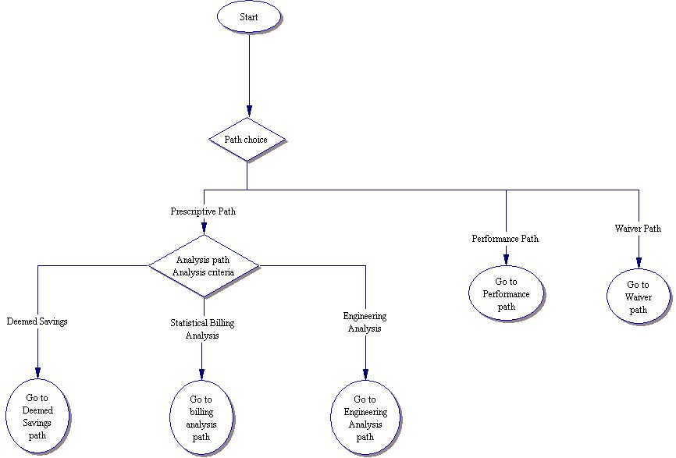

Deemed Savings Path
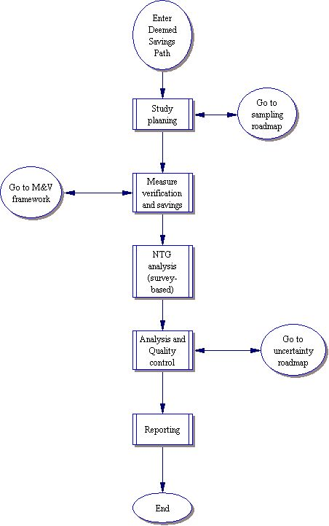

Billing Analysis Path

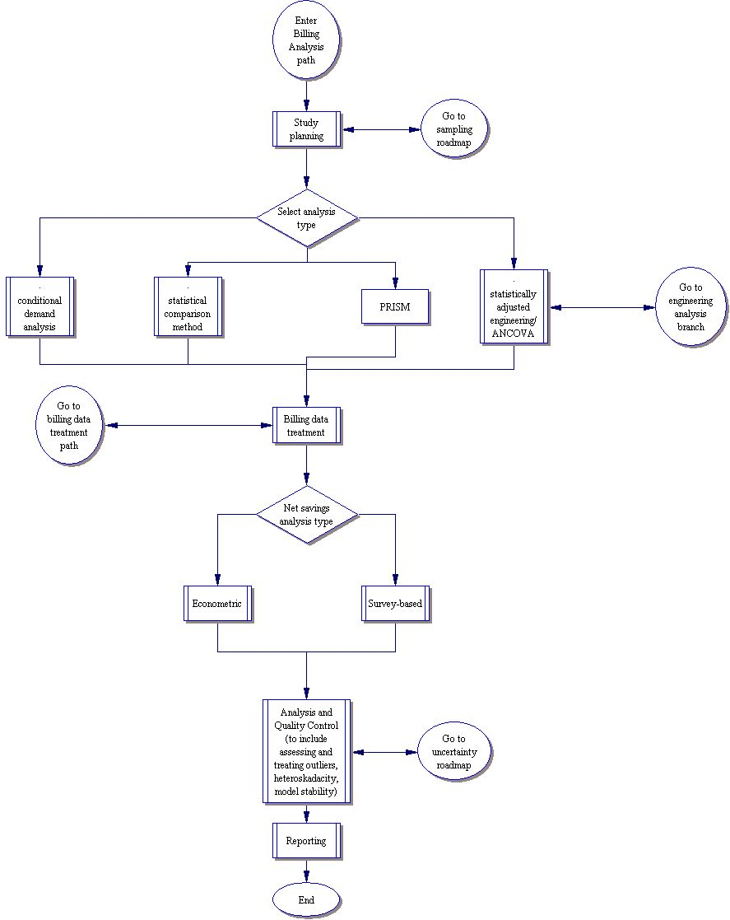

Engineering Analysis Path
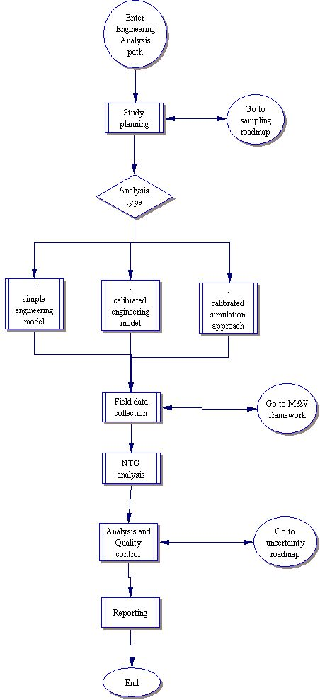

Billing Data Treatment Path

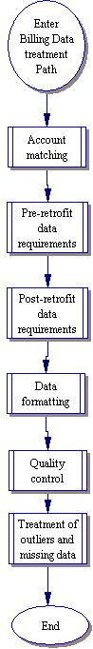

Measurement & Verification (M&V)

The M&V roadmap will provide a framework for making decisions about the scope and depth of M&V activities associated with energy efficiency programs. The purpose of M&V activities is to verify that measures promoted by a program were actually installed and to measure the gross electricity savings from the measure installation relative to some baseline pattern of use. The roadmap is based on the following principles and definitions:

- Measurement and verification, in this context, refers to data collection, monitoring and analysis activities associated with the calculation of gross energy savings from individual customer sites or projects. This refers to the “M&V” portion of “EM&V.” Program level gross and net impacts will be guided by the impact evaluation roadmap, which also contains a sampling section to guide decisions about individual site selection. The M&V roadmap is seen as a subset of the overall impact evaluation roadmap.

- The IPMVP and derivatives will be the overall “framework” for M&V activities (see summary below). Additional protocols will be developed to address measure verification as appropriate.

- M&V activities will primarily support program impact evaluations. Protocols for data collection to support other evaluation activities will be covered in their respective sections

- A “data warehouse” (such as the DEER database) will be developed as a resource for deemed energy savings and the engineering parameters used to calculate savings. These data will be delivered and stored in a standard format.

- Deemed savings and engineering parameters collected during the M&V analysis will include a reference indicating their source, uncertainty estimates when available, and limits of their applicability.

- The data warehouse will serve as a clearinghouse for engineering data related to measure performance. These data or other data submitted and approved in the program implementation plan will form the basis of the stipulated parameters described in the IPMVP Option A protocols

- An authority (such as CALMAC) will be mandated and funded to maintain performance measurements in the data warehouse. New studies reviewed and approved by the authority can be accepted into the database.

- The authority will periodically review gaps in the engineering data, and suggests specific overarching research projects to fill the gaps and reduce the uncertainty in engineering parameters.

- Deemed uncertainty values will be used to estimate the overall uncertainty in the building site savings calculations. The uncertainty estimate will address both instrument error and variations due to differences in equipment schedule and performance. The uncertainty on the savings estimate will likely be reduced by study-specific data collection. An up-front analysis of the uncertainty in the savings calculations will guide M&V resource allocation decisions.

- The M&V option employed (verification, options A-D) will depend primarily on the impact analysis chosen and the overall goals for impact results precision defined in the impact evaluation plan.

- The monitoring approach (spot measurements, on/off status logging, continuous measurements) and instrumentation selection (true electric power, proxy measurements, other process variables) taken depends primarily on the M&V option, analysis requirements, precision requirements and measure use variability.

- Monitoring duration depends on the measure use variability, climate dependence, and impact estimation precision goals.

IPMVP Option | How Savings Are Calculated
A. Partially Measured Retrofit Isolation  Savings are determined by partial field measurement of the energy use of the system(s) to which an ECM was applied; separate from the energy use of the rest of the facility. Measurements may be either short-term or continuous. Partial measurement means that some but not all parameter(s) affecting the building’s energy use may be stipulated, if the total impact of possible stipulation error(s) is not significant to the resultant savings. Careful review of ECM design and installation will ensure that stipulated values fairly represent the probable actual value. Stipulations should be shown in the M&V Plan along with analysis of the significance of the error they may introduce. | Engineering calculations using short term or continuous post-retrofit measurements and stipulations.
B. Retrofit Isolation  Savings are determined by field measurement of the energy use of the systems to which the ECM was applied; separate from the energy use of the rest of the facility. Short-term or continuous measurements are taken throughout the post-retrofit period. | Engineering calculations using short term or continuous measurements
C. Whole Facility  Savings are determined by measuring energy use at the whole facility level. Short-term or continuous measurements are taken throughout the post-retrofit period. | Analysis of whole facility utility meter or sub-meter data using techniques ranging from simple comparison to regression analysis.

D. Calibrated Simulation  Savings are determined through simulation of the energy use of components or the whole facility. Simulation routines must be demonstrated to adequately model actual energy performance measured in the facility. This option usually requires considerable skill in calibrated simulation. | Energy use simulation, calibrated with hourly or monthly utility billing data and/or end use metering.

Upper Level M&V Roadmap

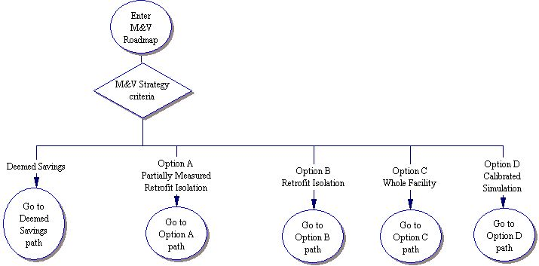

Deemed Savings Path
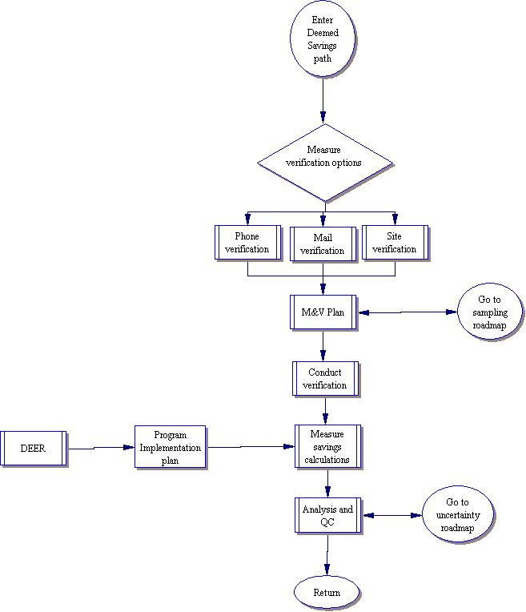

Option A Path
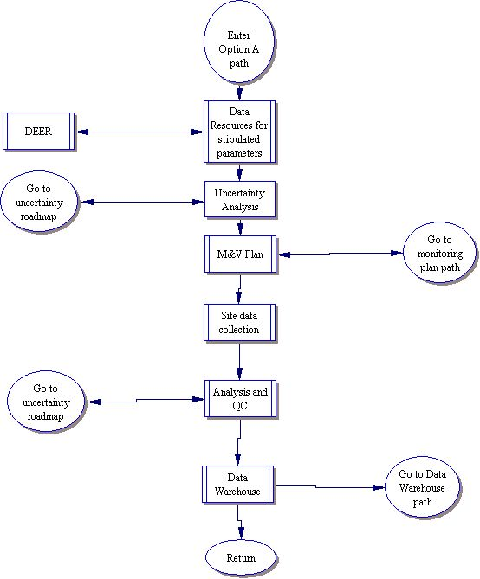

Option B Path
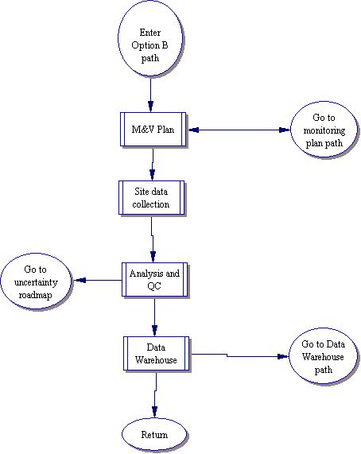

Option C Path

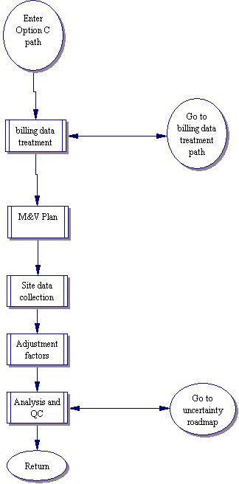

Option D Path
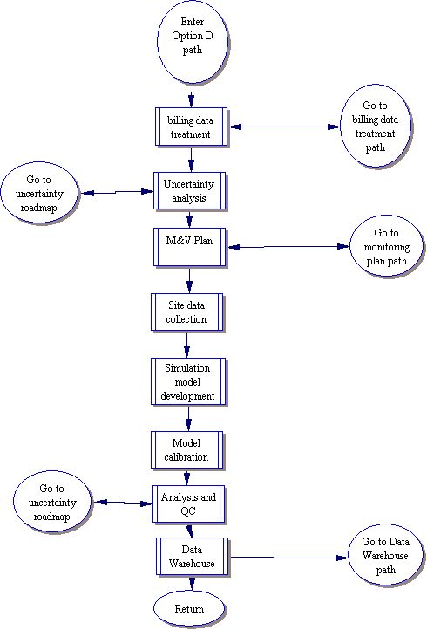

Monitoring Path
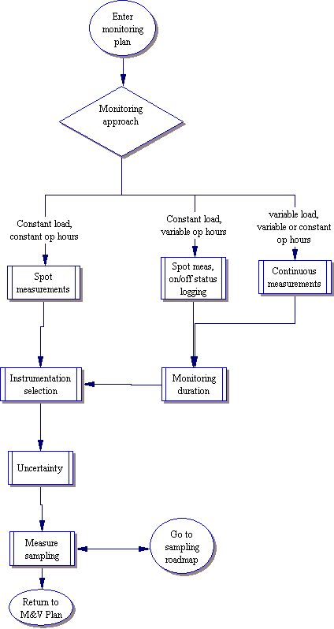

Data Warehouse Path
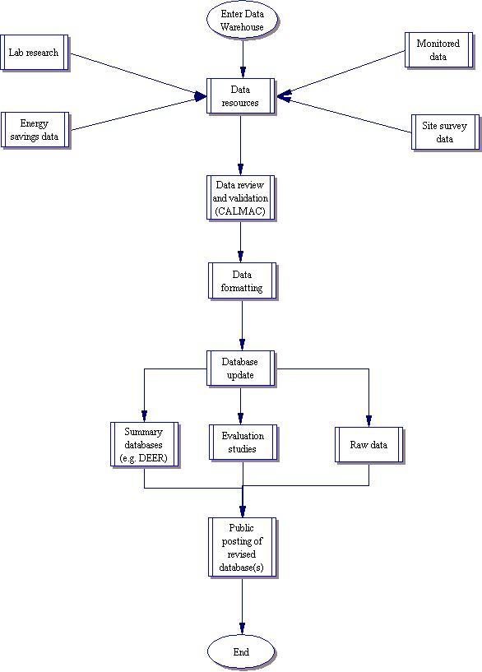

Process Evaluation Framework

- Process evaluations are a key component of all evaluation plans.

- Process evaluations cover a range of evaluation issues, including:
  - Program design, staffing, management and operations
  - Program information and support systems
  - Program targeting, marketing and out-reach efforts
  - Implementation timelines
  - Early or mid-stream program improvements (coordinated with M&V)
  - Participant satisfaction and services
  - Use of new practices or best practices
  - Design and use of marketing materials
It is designed to answer 3 questions: What works well?, What does not?, and How can the program be improved? This is done to also answer questions regarding the efficiency of program delivery, promotional strategy effectiveness, and level of customer and trade partner satisfaction.

- Some Framework decision criteria (e.g. influence of process improvements on improved energy and demand savings and/or cost effectiveness) lead directly to a required process evaluation while some lead indirectly to a required process evaluation. Priority is given to process evaluations where improved energy and demand savings are anticipated.

- There may or may not be a need to conduct a process evaluation depending on the specific program history and the previous evaluations.

- Process evaluations should be conducted after the program is allowed enough time to establish, use and fine-tune operations and operational procedures. This period is typically 6 months following program start-up.

- Process evaluations should be conducted for all new programs and following major program design or operational changes, when vender or service provider changes are made, or when program goals, services or target markets have been or in some cases, adjusted.

- Process evaluations should use a variety of evaluation tools appropriate for the evaluation issues being examined, including:
  - Records reviews and assessments,
  - Tracking system reviews and testing,
  - Reviews of program materials and tools,
  - Interviews with program management and staff,
  - Interviews with policy makers, key stakeholders and market actors,
  - Interviews, surveys and focus groups with participants, non-participants, and other key stakeholders,
  - Other activities as needed to address researchable issues

- Experienced evaluation professionals should conduct process evaluations.

Market Evaluation

Guiding Principles Being Considered:
- If long-term market effects are being claimed (or used in benefit/cost estimates) – then Market Evaluations need to occur.
- If other programs are offered that target the same market, then market evaluations need to be consolidated and conducted at the portfolio or market sector level. (Primary importance is capturing all of the program-induced market effects and limit double-counting, rather than trying to divvy up per-program effects.)
- Evaluation = Field testing assumptions made in program theories and logic models as well as in the program plans and design documents.
- Program theory and logic models (PT/LM) are an important tool that needs to inform the market evaluation planning process.
- PT/LM needs to be included in Evaluation Plan and in what the evaluator evaluates, i.e., 1st step in the evaluation process is an assessment of PT/LM about how the market operates and how the program will effect a change, followed by the development of testable hypotheses and alternative hypotheses that need to be addressed in the evaluation effort.
- Causality assessment must be made to claim any market effects savings, savings must be “net”. (See bullets below.)
- Savings are net if they are net of forecasted slope of the changes that would have occurred without program interventions (reference prior Framework)
This is one tool for indicating net effects and one where field data must support the analysis by field testing the models assumptions.
- Market comparison studies may also be able to provide net.
- Quasi-experimental design or experimental design could also be used to determine net.
- Long-term market effects can only be claimed for benefit/cost (or savings for portfolio aggregation) if they are proven to both be net and, if they are provided from market changes caused by the program and are sustainable market changes. Sustainability must be critically evaluated.
- If sustainability isn’t obvious (codes/standards/market dominance, profitability to promoter without subsidies) then post-program follow-up must be budgeted and planned.

Expect project report will:
- Describe sequence of market characterization, baseline, verification of PT/LM, market progress, and need for causality evaluation plan and measurement
- Refer to prior Framework and other work as applicable

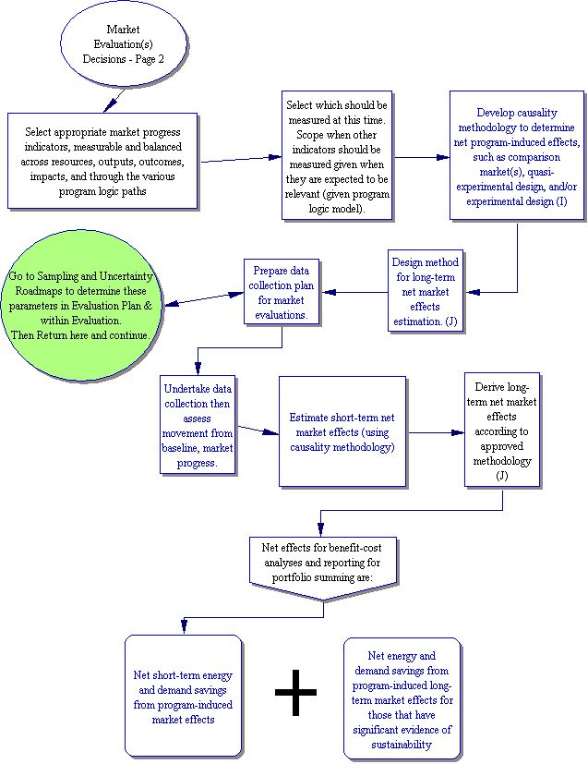

Information and Education Framework

- Information and education programs must have a clearly articulated program theory that details what the program will do, how it will be done, and how the program’s actions are expected to lead to the desired effects. The program theory should identify program goals and the expected barriers to the accomplishment of the goals as well as a description of how the program’s operations are expected to overcome the anticipated barriers.

- Programs that claim to have informational or educational effects should be able to demonstrate those effects via a program effects evaluation. The program evaluation should focus on documenting the degree to which the desired effects identified in the program theory are accomplished including:

  - Type and size of population reached,
  - Level of education effects achieved,
  - Measures taken as a result,
  - Number of participants channeled into other programs,
  - Effects of program on market operations,
  - Other effects as indicated in the program theory.

- In some cases the cost to conduct the information or education program effects evaluation may be prohibitive. In these cases the implementation organization must request and obtain a waiver to the effects evaluation requirement. The waiver request should suggest alternative approaches for assessing program effects when possible. The waiver review process may examine and recommend alterative approaches that can reduce costs. Coordinating the program effects evaluation for programs that provide referrals to other programs with the process and impact evaluations of the programs receiving the referrals can reduce costs and issues associated with multiple client contacts.

- Information and education programs require a process evaluation that examines the ability of the program to cost-effectively accomplish its stated goals and provide value and satisfaction to the program participant. These evaluations should follow the process evaluation framework.

- If the information and education program has market transformation goals the evaluation should include a market effects evaluation using the market effects framework. In many cases this evaluation may need to be incorporated into an evaluation across several programs or across a market sector.

(More detailed next steps, Sheet #2, are still under development.)

Non Energy Benefits Evaluation Framework

- The NEB evaluation framework is designed around a set of criteria that leads to the inclusion of non-energy benefits evaluation when one or more of the following conditions apply:

  - Program participation is directly dependant on the value of the non-energy benefits to the participant,
  - The program theory relies on the presence of and value of the non-energy benefits to achieve cost-effective energy or demand savings,
  - The CPUC has an official policy to document one or more of the non-energy benefits associated with a specific program or group of programs,
  - The CPUC has specifically approved the use of evaluation funds to document the presence or value of one or more non-energy benefits.

- Non-energy benefits evaluation is generally considered a lower priority evaluation effort within the evaluation framework and is to be conducted once the other evaluation goals are addressed.

- In most cases the explicit goal of the non-energy benefits evaluation is provide evaluation results that can be used to increase the ability of the program to acquire energy benefits.

Next Steps After September 3rd and 4th CALMAC Meetings

- Continued work on the New Framework/Roadmap with adjustments made given feedback from CALMAC meeting.

- Please provide any additional comments September 17, 2003 to either Dr. Lori Megdal at megdal@bellatlantic.net or to Nick Hall at nphall@TecMRKT.com

- Next CALMAC meetings on this project are scheduled for:
- October 1, 2003 in the Los Angeles area
- October 2, 2003 in San Francisco

